PEACE-WORK-FATHERLAND

MINISTRY OF HIHGER EDUCATION

UNIVERSITY OF BUEA

PAIX-TRAVAIL-PATRIE

MINISTERE DE L’ENSEIGNEMENT SUPERIEUR

UNIVERSITY OF BUEA



**UNIVERSITY OF BUEA**

FACULTY OF ENGINEERING AND TECHNOLOGY

DEPARTMENT OF COMPUTER ENGINEERING

CEF 440: INTERNET PROGRAMMING AND MOBILE PROGRAMMING

UI/UX Design and implementation of a passenger positioning system

Presented by:

EMADE ROSINE NSAH..........................................................FE20A032

ETUGE GIDEON......................................................................FE20A036

NOUGHUE LEMOUPA FRANK..............................................FE20A092

TAJOUEGO DJUIDJA ESTRELA............................................FE20A107

TAMAH JUSTENE....................................................................FE20A108

**Course Instructor**: Dr Nkemeni Valery

Table of Contents

INTRODUCTION 2

Scope 2

Goal 2

DESIGN PROCESS AND TOOLS 2

UI/UX DESIGN 3

IMPLEMENTATION AND DEVELOPMENT 4

CONCLUSION 4

# INTRODUCTION

With the increasing demand for efficient and reliable transportation services, the taxi industry has become an essential part of our daily lives. However, the traditional method of hailing a taxi on the street or calling a taxi company has drawbacks in terms of convenience and accessibility. To address these issues, **JETME** has been developed to provide a more efficient and user-friendly way for passengers to find and book taxis.

### Scope

The scope of this project is to design and implement a user interface and user experience for a taxi passenger positioning system. Our objective is to provide an easy-to-use platform that allows passengers to locate nearby taxis, book rides, and track journey progress in real-time. The system aims to improve the overall experience for both the passenger and drivers as well as increase the efficiency of the taxi service in our country..

### Goal

The goal of UI/UX is to create a design that is not only visually appealing but also functional and user-friendly. This involves understanding the needs and behaviors of the target audience, creating a clear and intuitive navigation system, designing consistent and recognizable visual elements, and testing and iterating the design to ensure a positive user experience. We are here to make an idea of **JETME** visible for. So in the following pages, we will be discussing on the design interfaces and how they interact to suit the needs of the passenger and the drivers.

# DESIGN PROCESS AND TOOLS

To design the **JETME** application, we went through some processes and a series of tools to bring the designs to live.

We used the agile method of development to bring the UI/UX design to live.

**Why use the agile method?**

The agile method is a project management approach that is particularly well-suited to UI/UX design and implementation as it emphasizes flexibility, collaboration, and iterative development. Applying this method to the development of a taxi passenger positioning system, it would involve working closely with stakeholders, including taxi companies and passengers, to identify their needs and preferences.

Throughout the design and implementation process, our teams worked together to create a cohesive and effective user experience focusing on creating an intuitive and visually appealing interface

**Design and implementation tools**

These are software applications that we used to create visual designs. To ensure a user friendly design we made use of the following software designing and implementation tool.

**Figma:** This tool was used to bring out the designs of passenger positioning system

**Android Studio:** This tool was used to implement the designs that were created using the figma software

# UI/UX DESIGN

The different interface designs that were implemented with the system can be view below

#### Sign up

This page is to get the user details to create an account. Not every user is entitled to have an account in the application. Therefore this aspect is necessary to just the drivers and the users that will be involved in the booking process

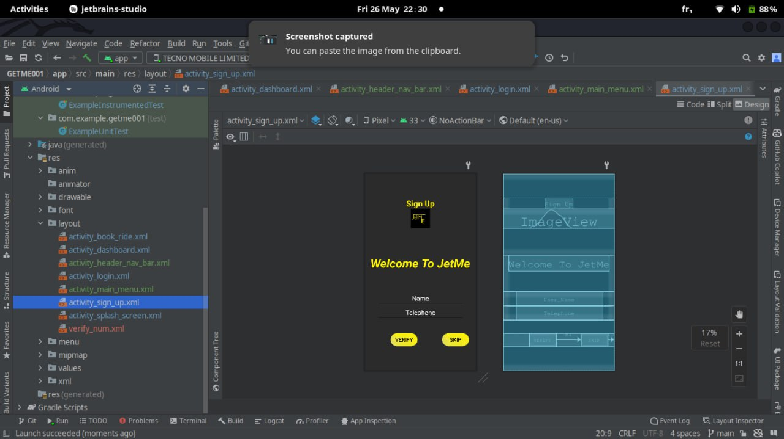

#### Login

This page is useful just to users who have accounts in the application. Not every user is obliged to have one

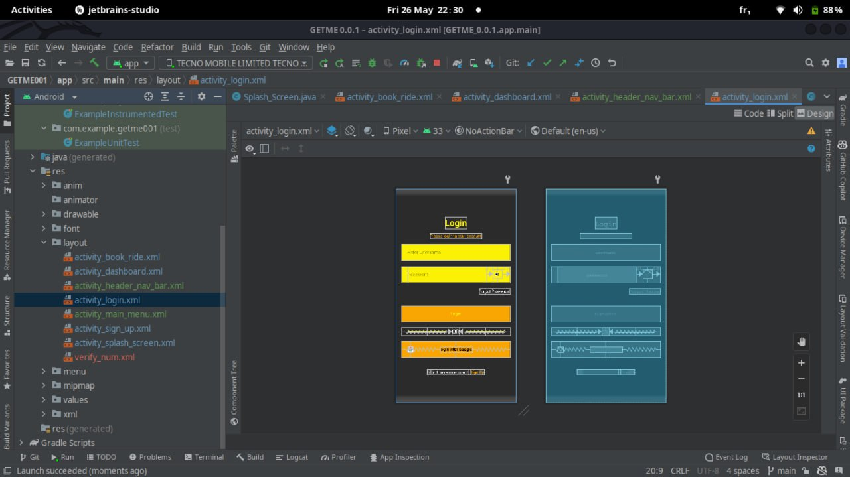

#### Dashboard

This page contains links to all the necessary actions that can be performed with the application. It is accessible by everyone depending on the type of user

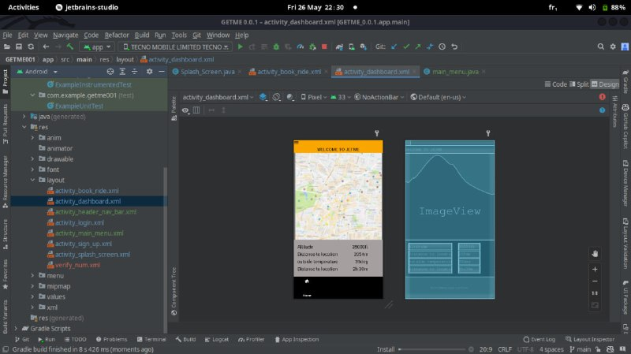

#### Menu

This section is associated with some pages as a pop up from the left. This will help the user to have access to other functions wherever page they are without necessarily going back to the dashboard

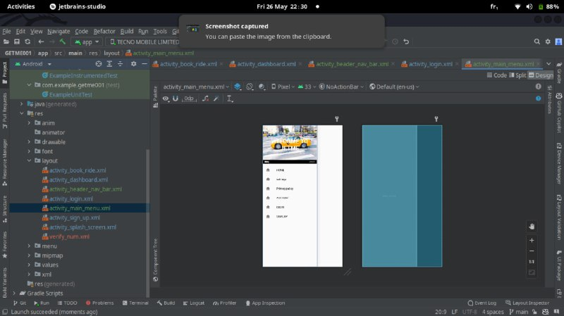

#### Book ride

This is functionality with the system that permits users willing to hire a taxi to gain access to one.

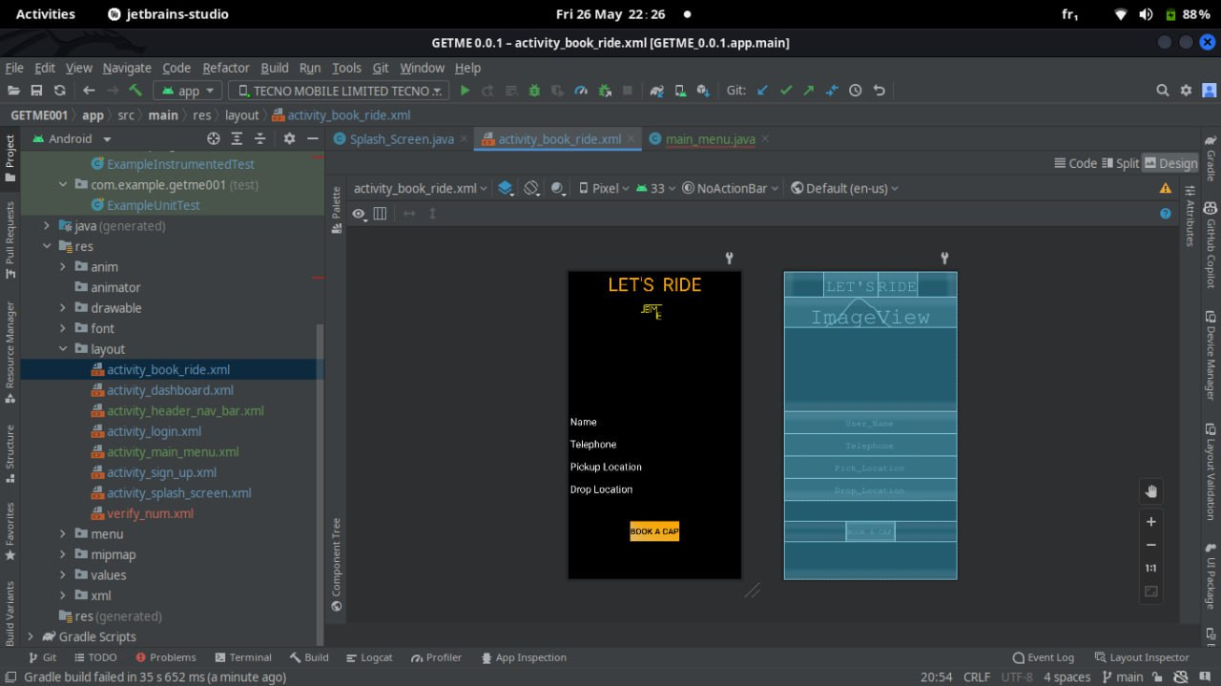

#### Verification

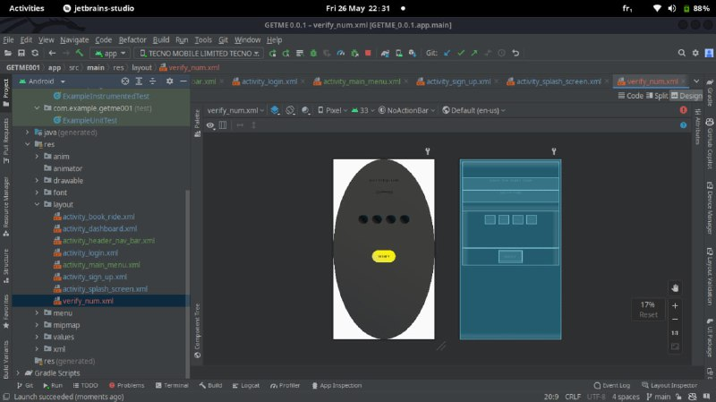

# IMPLEMENTATION AND DEVELOPMENT

The project will be implemented in two parts. We have the driver’s application and the passenger application which will inter-relate with one another.

#### Driver view

The drivers here are of two categories, that is the freelance drivers and the hired drivers. Both drivers open using the application are required to have an account. This account requires certain sensitive information to be uploaded. This information include the drivers name, car plate number and the drivers license. This is too collected for security purposes. A driver in the system is able to get passenger locations, view road distribution as well as locate traffic areas

#### Passenger view

Passengers being the principle users of the system have the possible to either create an account or not. The criteria for account creation for the user are upon booking a taxi. This is to ensure application credibility as well as security purposes. The passenger has the ability to book a taxi and get a normal taxi ride to required destination

# CONCLUSION

In conclusion, creating a user-friendly UI/UX design for a taxi passenger positioning system is crucial for ensuring its success and usability. Through careful user research we were able to create interfaces that are intuitive, visually appealing and easy to navigate, ultimately improving the overall user experience.

Furthermore, it is essential to understand the needs and preferences of the target audience to create personalized experiences that cater to their specific requirements. In doing so, users will be more likely to adopt the system, increasing customer satisfaction and improving overall efficiency.

IF IT CAN BE IMAGINED, THEN IT CAN BE CREATED